# How to Run

- Import project from github using following URL:

https://github.com/Alain98/WAA_Project.git

- Update "src/main/webapp/WEB-INF/spring/root-context.xml" file for database credentials.

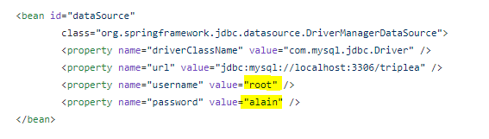

* Create database named ‘triplea’
* Application Login credentials:
  + Username: [ave@yahoo.com](mailto:ave@yahoo.com), Password: 12345